Table of Contents

PROGRAM SPECIFIC OUTCOMES (PSOs) 4

DO’S AND DON’T 7

DON’T 7

GENERAL SAFETY INSTRUCTIONS 8

Raj Kumar Goel Institute of Technology Ghaziabad 9

ISO 9001:2015 Certified 9

Department of Computer Science & Engineering 9

Raj Kumar Goel Institute of Technology Ghaziabad 11

ISO 9001:2015 Certified 11

Department of Computer Science & Engineering 11

Raj Kumar Goel Institute of Technology Ghaziabad 13

ISO 9001:2015 Certified 13

Department of Computer Science & Engineering 13

Title of the Mini Project / Internship Assessment 14

Raj Kumar Goel Institute of Technology Ghaziabad 2

ISO 9001:2015 Certified 2

Department of Computer Science & Engineering 2

DECLARATION 2

Raj Kumar Goel Institute of Technology Ghaziabad 3

ISO 9001:2015 Certified 3

Department of Computer Science & Engineering 3

**Raj Kumar Goel Institute of Technology Ghaziabad**

***ISO 9001:2015 Certified***

***5th KM. STONE, DELHI-MEERUT ROAD, GHAZIABAD (U.P)-201003***

**Department of Computer Science & Engineering**

**PO6: The engineer and society**: Apply reasoning informed by the contextual knowledge to assess societal, health, safety, legal and cultural issues and the consequent responsibilities relevant to the professional engineering practice.

**PO7: Environment and sustainability**: Understand the impact of the professional engineering solutions in societal and environmental contexts, and demonstrate the knowledge of, and need for sustainable development.

**PO8: Ethics**: Apply ethical principles and commit to professional ethics and responsibilities and norms of the engineering practice.

**PO9: Individual and team work**: Function effectively as an individual, and as a member or leader in diverse teams, and in multidisciplinary settings.

**PO10: Communication**: Communicate effectively on complex engineering activities with the engineering community and with society at large, such as, being able to comprehend and write effective reports and design documentation, make effective presentations, and give and receive clear instructions.

**PO11: Project management and finance**: Demonstrate knowledge and understanding of the engineering and management principles and apply these to one’s own work, as a member and leader in a team, to manage projects and in multidisciplinary environments.

**PO12: Life-long learning**: Recognize the need for, and have the preparation and ability to engage in independent and life-long learning in the broadest context of technological change.

### PROGRAM SPECIFIC OUTCOMES (PSOs)

**PSO1:** The ability to use standard practices and suitable programming environment to develop software solutions.

**PSO2:** The ability to employ latest computer languages and platforms in creating innovative career opportunities.

|  |  |
| --- | --- |
| **C40**7**.1** | Relate to the 'real' working environment and get acquainted with the organization structure, business operations and administrative functions. |
| **C40**7**.2** | Practice hands-on experience in the computer related fields so that they can relate and reinforce  what has been taught. |
| **C40**7**.3** | Develop synergetic collaboration with industry and the university in promoting a knowledgeable society. |
| **C40**7**.4** | Set up the stage for future recruitment by potential employers. |

|  |  |  |  |  |  |  |  |  |  |  |  |  |  |  |
| --- | --- | --- | --- | --- | --- | --- | --- | --- | --- | --- | --- | --- | --- | --- |
|  | **PO1** | **PO2** | **PO3** | **PO4** | **PO5** | **PO6** | **PO7** | **PO8** | **PO9** | **PO10** | **PO11** | **PO12** | **PSO1** | **PSO2** |
| **C40**7**.1** | **3** | **3** | **2** | **1** | **1** | **1** | **1** | **1** | **2** | **1** | **2** | **2** | **3** | **2** |
| **C40**7**.2** | **3** | **3** | **2** | **1** | **2** | **1** | **1** | **1** | **2** | **1** | **1** | **2** | **3** | **3** |
| **C40**7**.3** | **3** | **3** | **1** | **1** | **2** | **1** | **1** | **1** | **2** | **1** | **1** | **2** | **2** | **1** |
| **C40**7**.4** | **3** | **3** | **1** | **1** | **2** | **1** | **1** | **1** | **1** | **1** | **1** | **2** | **2** | **1** |
| **C40**7 | **3** | **3** | **1.5** | **1** | **1.75** | **1** | **1** | **1** | **1.75** | **1** | **1.25** | **2** | **2.5** | **1.75** |

**Raj Kumar Goel Institute of Technology Ghaziabad**

***ISO 9001:2015 Certified***

***5th KM. STONE, DELHI-MEERUT ROAD, GHAZIABAD (U.P)-201003***

**Department of Computer Science & Engineering**

# DO’S AND DON’T

* 1. Conform to the academic discipline of the department.
  2. Enter your credentials in the laboratory attendance register.
  3. Read and understand how to carry out an activity thoroughly before coming to the laboratory.
  4. Ensure the uniqueness with respect to the methodology adopted for carrying out the experiments.
  5. Shut down the machine once you are done using it.

# DON’T

1. Eatables are not allowed in the laboratory.
2. Usage of mobile phones is strictly prohibited.
3. Do not open the system unit casing.
4. Do not remove anything from the computer laboratory without permission.
5. Does not touch, connect, or disconnect any plug or cable without your faculty/laboratory technician’s permission.

**Raj Kumar Goel Institute of Technology Ghaziabad**

***ISO 9001:2015 Certified***

***5th KM. STONE, DELHI-MEERUT ROAD, GHAZIABAD (U.P)-201003***

**Department of Computer Science & Engineering**

# GENERAL SAFETY INSTRUCTIONS

1. Know the location of the fire extinguisher and the first aid box and how to use them in case of an emergency.
2. Report fire or accidents to your faculty /laboratory technician immediately.
3. Report any broken plugs or exposed electrical wires to your faculty/laboratory technician immediately.
4. Do not plug in external devices without scanning them for computer viruses.

**)**

# Raj Kumar Goel Institute of Technology Ghaziabad

## ISO 9001:2015 Certified

***5th KM. STONE, DELHI-MEERUT ROAD, GHAZIABAD (U.P)-201003***

*Tel: (0120) 2788409, Fax: (0120) 2788447*

# Department of Computer Science & Engineering

***Guidelines for* Mini Project / *In*ternship Assessment *(*K*CS- 75*2*)***

***Report Writing***

**Order of the Contents**

1. Title page
2. Declaration
3. Vision, Mission, PEO, PO, PSO, CO, CO-PO-PSO Mapping
4. Abstract (300-500 words)
5. Table of contents with page numbers
6. List of fig & tables with page numbers
7. Copy of Certificate issued by company.
8. Introduction (should not exceed 2 pages)
9. Problem Statement and Solution approach (should not exceed 3 pages)
10. Facilities required for proposed work
11. Real world Application (should not exceed 1 page)
12. Evaluation form shared by Department on Company’s Letter Head

**Size:** Standard paper size A4 should be used.

**Page Number:** Page should be numbered consecutively and clearly. No page number should be indicated on title page and declaration; however pages are to be counted from title page. From title page to abstract page Greek numbers should be used. From main text to end of thesis Indian numerals should be used. All typing should be on right hand pages only.

**Margin:** Top 1.0”, Bottom 1.0” Left 1.5” Right 1.0”

**Line spacing:** 1.5 **Font Size:**

|  |  |  |
| --- | --- | --- |
| • | Main heading Size | 16 (Bold) |
| • | Sub heading e.g 1.1 | 14 (Bold) |
| • | Subtitles e.g. 1.1.1 | 12 (Bold) |
| • | Text (script) | 12 |

# Raj Kumar Goel Institute of Technology Ghaziabad

## ISO 9001:2015 Certified

***5th KM. STONE, DELHI-MEERUT ROAD, GHAZIABAD (U.P)-201003***

*Tel: (0120) 2788409, Fax: (0120) 2788447*

# Department of Computer Science & Engineering

**Font: Times New Roman**

Avoid underlines and colon i.e. :

To indicate a figure, write below the figure and the format should be **Fig.1.5.**

To indicate a table, write above the figure and the format should be **Table1.5.**

Never write report in first person i.e. “I will do this”. Instead write author….

**Text:** Before producing the final copies of a report the candidate should ensure that all the spelling, grammar and punctuation.

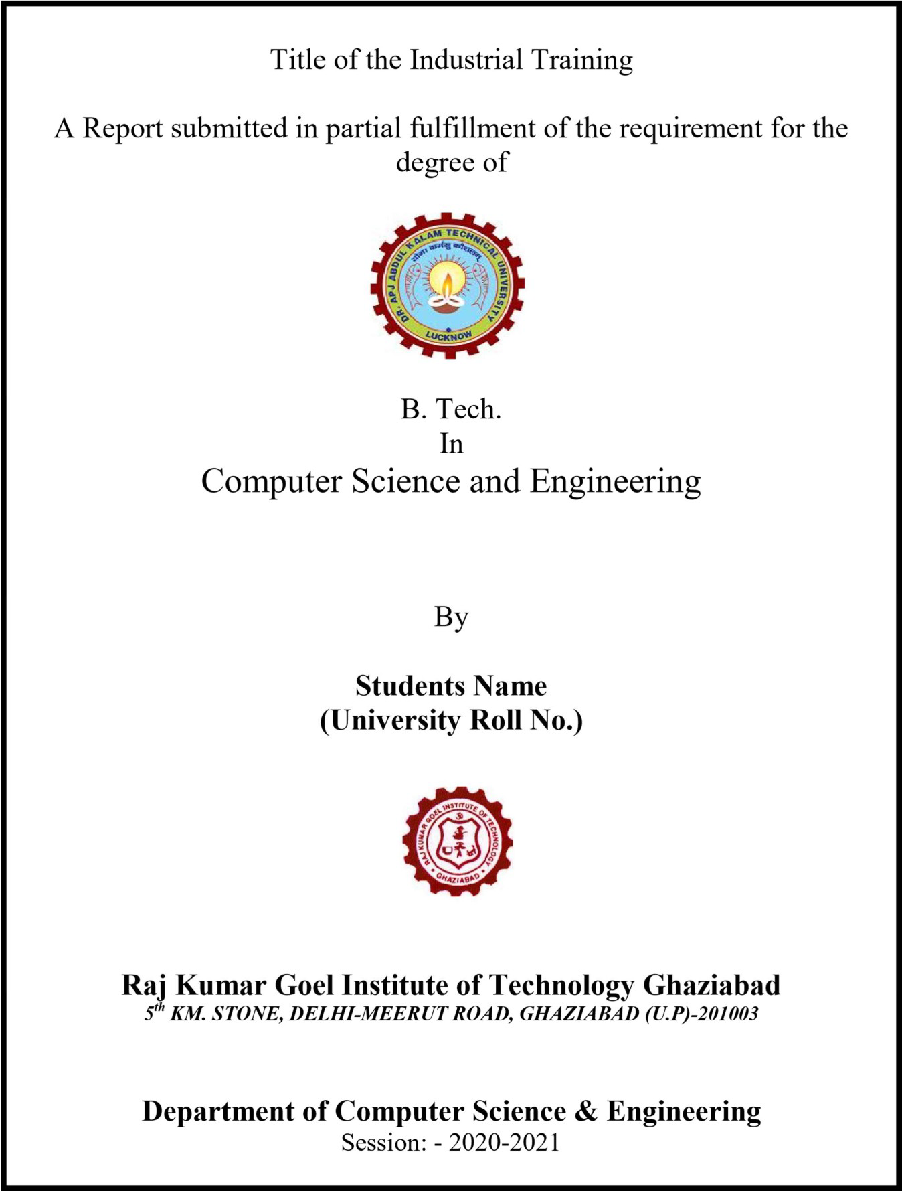

### Title of the Mini Project / Internship Assessment

**MINI PROJECT**

2022 -2023

# Raj Kumar Goel Institute of Technology Ghaziabad

## ISO 9001:2015 Certified

***5th KM. STONE, DELHI-MEERUT ROAD, GHAZIABAD (U.P)-201003***

*Tel: (0120) 2788409, Fax: (0120) 2788447*

# Department of Computer Science & Engineering

# DECLARATION

This is to certify that the Mini Project Report Entitled “………………………………..

…………………………………………………………..” which is being submitted in partial fulfillment of the requirement for the award of degree B. Tech in Computer Science and Engineering to RKGIT, Ghaziabad (Dr. A.P.J. Abdul Kalam Technical University, Lucknow) comprises only original work and studies carried out by the students themselves. The matter embodied in this work has not been submitted for the award of any other degree.

Date: Name of Student

(Roll No.)

# Raj Kumar Goel Institute of Technology Ghaziabad

## ISO 9001:2015 Certified

***5th KM. STONE, DELHI-MEERUT ROAD, GHAZIABAD (U.P)-201003***

*Tel: (0120) 2788409, Fax: (0120) 2788447*

# Department of Computer Science & Engineering

Mini Project / Internship Assessment (KCS-752) Manual (CS, VII SEM)

**EVALUATION**

As per the AKTU norms Industrial Training progress shall be evaluated by the internal examiner at the end of the semester. However, there will be continuous monitoring of the Industrial Training progress report during the semester and distribution of marks shall be as follows:

**B.Tech. Final Year Industrial Training Assessment (Internal)**

**Date of Assessment (DD/MM/YYYY): / /2022……………………………**

|  |  |
| --- | --- |
| **Project Assessment Parameter(s) Total Marks(50)** | **Student Roll No** |
| Application of Engineering Principles and software/mathematical tools/Latest technology(10) |  |
| Quality of the report writing(layout, structure, written and graphical material, referencing)(10) |  |
| Presentation Skills(10) |  |
| Innovation and understanding (level of difficulty, innovation and understanding of work completed)(10) |  |
| Outcomes (results, conclusions and learning outcomes achieved)(10) |  |